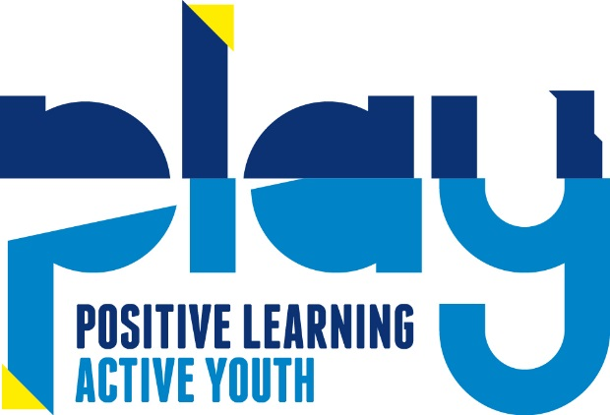

PLAY – Registration consent information

Dear Parents and carers,
Please take a minute to read the following consent statements before registering your child.

- I consent to my son/daughter being allowed to take part in PLAY sessions accompanied by PLAY registered staff.

First Aid Treatment consent:

- To the best of my knowledge my son/daughter is fit and healthy for the purpose of the activity.

- I consent that first aid treatment can be given to my child if required by a member of qualified PLAY staff.

- I consent to a member of staff accompanying my child to hospital if required.

PLEASE NOTE:
If you consent to the above statements, please tick the First aid consent box on the registration form.

Photograph and Video consent:

- I give permission to take photographs and / or video of my child.

- I consent to PLAY to use photographs and/or video of my child for social media and promotion use only.

PLEASE NOTE:
If you do not consent to the above statements, please tick the Photograph and Video consent box on the registration form to decline.

Behavior Contract Consent:

- I have ensured that my son/daughter understands that it is important for his/her safety and for the safety of the group that any rules and any instructions given by PLAY staff are followed.

Please read these statements to your child:

- You are expected to treat yourself, the other children, and the adults at PLAY with respect.
- You are to be polite and courteous in your actions and conversations with others (do not use offensive language).
- You are expected to keep yourself safe and to help your friends keep themselves safe by following the PLAY rules (if you or someone else might get hurt, don’t do it).
- You are expected to use your own materials, school materials, and equipment in a safe manner so they are not damaged or lost.
- You are expected to listen and respond to directions given to you by adults the first time.
- What happens if your behavior is inappropriate? You may receive a reminder of the rules. If you choose to not listen to the reminder, you may be given a time out. An adult will discuss your behavior with you after you cool down.
- Remember to treat everyone the way you like to be treated.
- If someone hurts you, threatens you, teases you, or plays unfairly, tell them how you feel. If they won’t listen, ask an adult to help you. The adults will help you learn ways to care for yourself in these situations.
- Remember all of us have bad days. You are welcome to share your feelings with the adults at PLAY any time you like.
- If you have any questions about how you are expected to behave, please ask an adult.
PLEASE NOTE:
If you consent to the above statements, please tick the Behavior contract consent box on the registration form.

GDPR – General Data protection regulations
PLAY is legally required to inform you of the new government regulations. The General Data Protection Regulation (GDPR) is the new European legal framework for the protection of personal data. The regulation officially comes into effect on 25th May 2018. It comes in place of the 1995 Data Protection Directive (DPD) and, prior to Brexit, would have led to the UK implementing a new act in place of the existing Data Protection Act 1998.
PLAY gains personal data from source:
- The data controller for PLAY at St Mary’s is George Hance and we do not provide your details to third parties;
- Your personal data is securely protected and encrypted;
- The purpose of this data collection is to meet Ofsted guidelines, to obtain emergency contact details for the protection of the children and to communicate to our families about up and coming events;
- We will provide slightly more information on our invoices and our parent handbook, about the management of this information;
Parental/ Carers rights under the GDPR:
- You have the right to access your personal information at any time (PLAY will be able to send you your original booking form).
- The updating of personal information is the responsibility of the parent/ carer and can be done at any time FREE of charge by contacting george@plaype.co.uk
- You may ask to remove any specific personal data at any time by contacting george@plaype.co.uk
Management of your personal data:
- PLAY will hold the following information: your Child’s name/ DOB/ year group/ school they attend/ Medical and Allergy information. PLAY will also hold the parents/carers emergency contact name/ telephone number/ email address/ postal address and your child’s safe password. This is all classed as personal data;
- PLAY will use this personal data to contact you in an emergency, to contact you regarding bookings/ payment and to contact you about are up and coming events.
- PLAY is only collecting the relevant information required by Ofsted and for the day to day communication with parents and carers.
- PLAY will not be using personal data to profile clients or for any analysis of data.
- PLAY will retain personal information for a 3 years after the child has left.
- The parent and carer can with draw consent at any time by contacting george@plaype.co.uk

Refunds and Alterations to Bookings

- All refunds are given at the discretion of PLAY.

- Any alterations to bookings must have at least 4 weeks notice or happen at the end of a half term. Whatever happens soonest.

- Payment changes will come into effect at the end of the 4 week notice period or at the start of a new half term. Whatever happens soonest.

- You are not entitled to a refund or session in credit due to non-attendance.

- A place will available to your child for all sessions booked and paid for. Choosing not to attend does not result in a refund or session in credit

- Should PLAY not be able to put on a session in fault of PLAY a full refund shall be issued within 10 working days

- Should PLAY not be able to put on a session due to school closures of any kind not in fault of PLAY including but not limited to fire, flood, gas leak, heating malfunction, illness outbreak, property damage etc. A refund shall not be issued. If the closure lasts for more than 2 weeks a full refund shall be issued from the end of the 2 week closure period.

