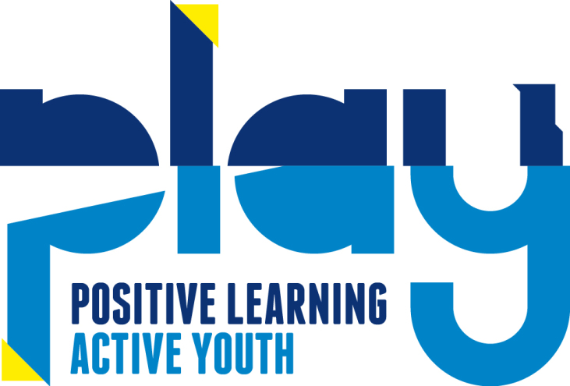

Illness Policy

Statement of Intent
PLAY believes that the health of children is of paramount importance. We make our Setting a safe and healthy place for children, parents, staff and volunteers.

Definition of an infectious illness is: An infection which is spread from one person to another or from one part of the body to another.

Aim
We aim to make children, parents and staff aware of healthy issues to enable children to thrive in a healthy environment. We take very seriously our duty to protect children and adults who may be receiving treatment for any disease or illness and recognise it is very important to know of any infectious illness in case special steps need to be taken. Pregnant mothers are also at risk from certain illnesses and children and adults who have not received all the usual childhood immunisations.

Methods
All our staff ensure that children receive appropriate care and attention if they become sick while in the setting, so ensuring that children are comfortable and that the risk of cross-infection is minimised. We endeavour to give parents health protection and prevention literature as often as possible. We have a list of local agencies to help parents, if necessary.

We request parents to:

- Keep emergency contact details up to date, in case parents have to be contacted in an emergency.

- Keep to the recommended exclusion period for different illnesses. Our staff operate a consistent approach and will sensitively discuss with parents why their child needs to be excluded. The exclusion period for all infections is implemented. Parents can find the exclusion times by contacting their GP or by contacting the Setting. We have a guide on the available on request.

- Notify the Setting by telephone, on the first day of illness, if a child is unable to attend. We will inform other parents and carers of infections and sickness if necessary but we will respect confidentiality by not identifying the child(ren) concerned.

- Inform the Setting of any medication a child may have been prescribed by a G.P. We ask parents to keep their child home for a period of 48hours when prescribed antibiotics. Information will be shared with the school, where necessary.

We can refuse admittance to children who have a temperature, new persistent cough, loss of smell or taste, sickness and diarrhoea or a contagious infection or diseases.

Sickness and Diarrhoea
Parents and carers are requested to keep their children away from the setting if their child has been vomiting or has diarrhoea until 48 hours after the last occasion. (although it is recognised that for children under 5 a longer period of exclusion may be required).

Covid 19
We ask parents and carers to keep their children home if they, or anyone in their household displays any of the following: high temperature, new persistent cough, loss of taste or smell. They must follow current Government guidance and only return to the setting when it is safe for them to do so. Failure to do so could result in the setting having to close for 2 weeks.

Nits and lice
If a child has nits or lice:

- We will give advice to the child’s parent and recommend treatment be undertaken.
- We will not suspend the child or treat them any differently in a session.
- We will treat the matter as confidential.
- We will inform all parents of the problem, either verbally, by a poster on the door, or by a letter, to monitor their own child. We will respect confidentiality by not identifying the child(ren) concerned.

HIV
- Human Immunodeficiency Virus may affect children or families attending the Setting. Children or families are not excluded because of HIV.

Prevention of sunburn:
Children become ill if exposed skin is in contact with strong sunshine. We ensure that children:

- Will wear t-shirts etc. when playing outside.
- Will be encouraged to wear hats at all times.
- Reconvene inside if the sun is very strong.

We ask parents to:
- Apply suncream before each session. (please see member of staff for details).
- Provide appropriate light long sleeved tops and protective head wear.

In the event of a child becoming ill whilst at Setting:

- If a child shows any sign of possibly being unwell, including being drowsy/falling asleep, the parent/carer, or another adult designated by the parent will be contacted immediately.
- The child will be attended by a paediatric first aider and will be placed in a quiet area in the setting. The child will not be left alone.
- Where necessary the child will be changed, made comfortable and reassured.
- Other children will be kept away from the area.
- All staff are aware of parents’ wishes such as cultural and religious beliefs, when dealing with a sick child.
- We will telephone parent(s) later in the day or the following morning to enquire how the child is feeling and if there is a reason for the illness.

Animals
- We ensure animals visiting our Setting are free from disease, safe to be with children and do not pose a health risk.
- Children wash their hands after contact with animals

At PLAY we have a duty to prevent the spread of infectious illnesses and list below the communicable diseases, which are notifiable to our Local Authority under the Public Health (Infectious Diseases) Regulations 1988. We notify Ofsted initially by telephone, and then by writing, of any child who has a serious illness, the death of a child whilst in our care and of any infectious diseases that a qualified medical person considers notifiable.

Communicable Diseases:
List of notifiable diseases (NOIDS)
Diseases notifiable to local authority proper officers under the Health Protection (Notification) Regulations 2010:
- Acute encephalitis
- Acute infectious hepatitis
- Acute meningitis
- Acute poliomyelitis
- Anthrax
- Botulism
- Brucellosis
- Cholera
- Diphtheria
- Enteric fever (typhoid or paratyphoid fever)
- Food poisoning
- Hemolytic uraemic syndrome (HUS)
- Infectious bloody diarrhea
- Invasive group A streptococcal disease
- Legionnaires’ disease
- Leprosy
- Malaria
- Measles
- Meningococcal septicemia
- Mumps
- Plague
- Rabies
- Rubella
- Severe Acute Respiratory Syndrome (SARS)
- Scarlet fever
- Smallpox
- Tetanus
- Tuberculosis
- Typhus
- Viral hemorrhagic fever (VHF)
- Whooping cough
- Yellow fever
Report other diseases that may present significant risk to human health under the category ‘other significant disease’.
Links to legislation and key guidance

- Childcare Act 2006
- The Health and Safety at Work Act 1974
- The Human Rights Act (HRA) 2002
- Public Health (Control of Disease) Act 1984
- Public Health (Infectious Diseases) Regulations 1988
- Health Protection Agency Act 2004
- Health Protection (Notification-NOIDS) Regulations 2010

Links to the Statutory Framework for the Early Years Foundation Stage – Welfare Requirements – Section 7 - Safeguarding and Promoting Children’s Welfare – Illnesses and Injuries

Further information
Department of Health – www.dh.gov.uk
Information regarding health issues in schools and nurseries – www.wiredforhealth.gov.uk Health and Safety Executive – www.hse.gov.uk

This policy was adopted by: PLAY | Date: 7/12/2020
To be reviewed: December 2021 | Signed: C Emment

This policy was adopted by the Staff and Management at PLAY, November 2016

CONTINGENCY ARRANGEMENTS FOR EMERGENCIES

UNWELL CHILD
Children who are unwell will not be admitted to Setting because:

- The relatively confined area can cause infection to spread rapidly.

- Staffing levels are set to care for well children only and adequate care cannot be given to a child who arrives at the Setting unwell.

Parents/carers who arrive at the Setting with children who are unwell will be required to take them home.

SICKNESS
In the event of a child showing signs of, or becoming ill, whilst at Setting:

- The parent or guardian will be contacted immediately.
- The child will not be left unattended.
- The child will be changed, made comfortable, and reassured.
- Other children will be kept away from the area.
- The staff will use rubber gloves and aprons when clearing up any body fluids.
- Soiled clothing will be put into plastic bags for collection by parents.
- Soiled cleaning cloths and other materials will be doubled wrapped in plastic bags and disposed of using the correct procedure.
- The child will await collection with a member of staff in a quiet area away from other children.
- All staff are aware of parents wishes such as cultural and religious beliefs, when dealing with a sick child.

MANAGING SPILLAGES OF BODILY FLUIDS
- Spillages of bodily fluids must be dealt with quickly. Other persons must be kept away from the spillage until it has been effectively dealt with.
- The person carrying out the cleaning must ensure all cuts are fully covered with a waterproof plaster. They must always wear disposable gloves and an apron.
- The spillage must be covered with absorbent paper. The paper and spillage must then be cleared away and disposed of in a yellow waste incineration bag.
- The area must then be washed with a strong solution of detergent and wiped dry using disposable paper.
- Disposable gloves and other materials used must be disposed of in a yellow waste incineration bag.
- Hands must always be washed after handling bodily fluids.

IN EXTREME CASES OF EMERGENCY
- An ambulance is called and the parent/s is/are called.

Contingency arrangements for staff absences and emergencies

To be implemented by the Manager or Supervisor of the Day

Staff are required to contact the team leader at home as early as possible before the session to be worked to inform her of their absence and the reason for it. It is important we know the nature of any sickness within the Setting, as it will help us to protect the health of everyone who comes into contact with the group. Names and telephone numbers of people willing to stand in to cover staff absences are kept in the staff file. Wherever possible these people will have had the relevant security checks carried out.

In the event of a member of staff having to leave the premises for an emergency and putting the staff ratios at risk:

- Members of staff not working that session will be contacted.
- Bank staff will be contacted.
- In the event of not being able to get emergency cover parents will be contacted to take children home in the following order.
- Parents living close by, who do not work.
- Parents from further a field, who do not work.
- Named adults standing as emergency contact for working parents. In this case parents will also be contacted if possible at their place of work to inform them of the situation.

This process will continue until the numbers present meet staff ratios.

This policy was adopted by: PLAY | Date: November 2018
To be reviewed: November 2019 | Signed: C Emment

This policy was adopted by the Staff and Management at PLAY, November 2016

