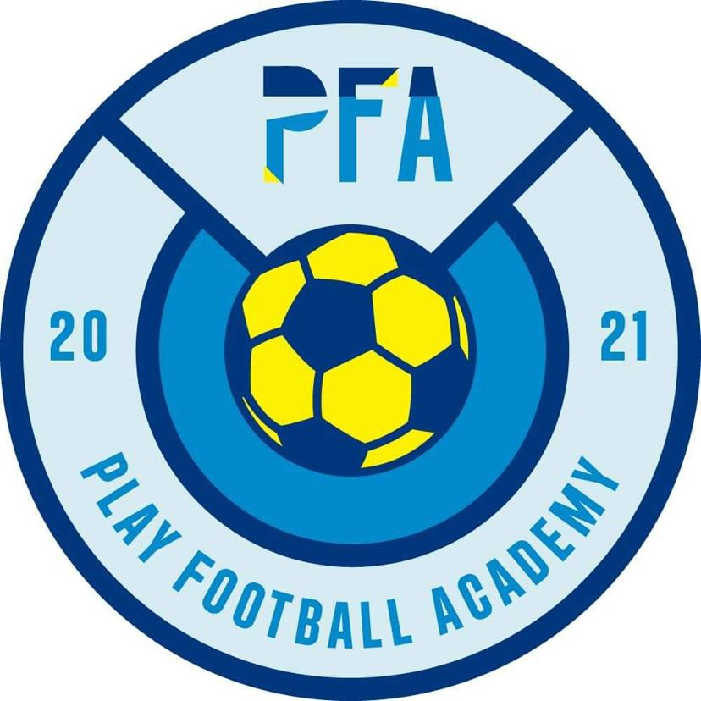

PLAY Football Academy – Registration consent information

Dear Parents and carers,
Please take a minute to read the following consent statements before registering your child.

- I consent to my son/daughter being allowed to take part in PFA sessions accompanied by PFA registered staff.

First Aid Treatment consent:

- To the best of my knowledge my son/daughter is fit and healthy for the purpose of the activity.

- I consent that first aid treatment can be given to my child if required by a member of qualified PFA staff.

- I consent to a member of staff accompanying my child to hospital if required.

PLEASE NOTE:
If you consent to the above statements, please tick the First aid consent box on the registration form.

Photograph and Video consent:

- I give permission to take photographs and / or video of my child.

- I consent to PFA to use photographs and/or video of my child for social media and promotion use only.

PLEASE NOTE:
If you consent to the above statements, please tick the Photograph and Video consent box on the registration form.

Behavior Contract Consent:

- I have ensured that my son/daughter understands that it is important for his/her safety and for the safety of the group that any rules and any instructions given by PFA staff are followed.

Please read these statements to your child:
Behaviour (Children)
Children and staff have created rules for acceptable behaviour whilst at PLAY FOOTBALL ACADEMY. These are displayed at PLAY AT SALTDEAN LTD for everyone to see.
We have a clear Behaviour Management Policy, a copy of which is distributed to all parents and carers:
PLAY FOOTBALL ACADEMY promotes an atmosphere of care, consideration and respect for everyone attending: children, staff and visitors.
We encourage appropriate behaviour through praise for good behaviour; emphasis on co-operation with staff within PLAY FOOTBALL ACADEMY and sharing and talking to children with the courtesy that we expect from them and engaging children in activities.
PLAY FOOTBALL ACADEMY has procedures for dealing with unacceptable behaviour. We recognise that poor behaviour can occur from time to time for reasons that are not always evident.
However, if your child is violent, or if their behaviour poses an immediate danger to themselves or others, we will require you to collect them from PLAY FOOTBALL ACADEMY immediately. We reserve the right to permanently exclude a child from PLAY FOOTBALL ACADEMY. See our Suspensions and Exclusions Policy for full details.
Behaviour (Adults)
We will not tolerate from any person, whether a parent, carer or visitor: Bullying; aggressive, confrontational or threatening behaviour; or behaviour intended to result in conflict. PLAY FOOTBALL ACADEMY is a place of safety and security for the children who attend and the staff who work here, and we reserve the right to ban anyone exhibiting inappropriate behaviour from our premises. See our Aggressive Behaviour Policy for more details.
PLEASE NOTE:
If you consent to the above statements, please tick the Behavior contract consent box on the registration form.

PFA PARENT BEHAVIOUR CONTRACT
It is the goal of PLAY FOOTBALL ACADEMY to create and maintain a respectful, peaceful, and secure environment for children and staff in partnership with parents and families. Your child’s place can only be confirmed once this has been signed and returned to the Coaches.
Parents are expected to:
● Approach staff respectfully to help resolve issues or concerns.
● Recognize that PLAY FOOTBALL ACADEMY staff’s first priority is the safety, supervision and engagement of children. Therefore, staff may indicate that it would be more effective to schedule an appointment to speak one on one with parents when a lengthy discussion or confidentiality is required.
● Recognize that some conversations are private and need to take place away from the children.
● Communicate with staff in a calm, respectful manner.
● Work with staff at PLAY FOOTBALL ACADEMY for mutual understanding and the benefit of their children.
● Seek to clarify a child’s version of events with PLAY FOOTBALL ACADEMY in order to bring about a peaceful solution to any issue.
● Actively participate in plans to support their own child’s behaviour.
● Avoid using staff as threats to admonish children.
● Reinforce expectations with your child to follow PLAY FOOTBALL ACADEMY rules.
● Be familiar with the PLAY FOOTBALL ACADEMY Behaviour Policy and support children to show this behaviour consistently.
● Reinforce expectations with your child to adhere to the PLAY FOOTBALL ACADEMY Behaviour Policy.
● Bring questions, comments, or concerns regarding programming matters directly to the attention of the Site Director – Chris Emment.
● Acknowledge staff upon entering and exiting the site to ensure a smooth transition of supervision responsibilities of your child.
● Contact the Site Director – Chris Emment for questions, comments, or concerns regarding administration matters (registration, invoicing, waiting lists, policies, etc.)
● Partner with PLAY FOOTBALL ACADEMY to create an environment where everyone feels safe, welcomed, respected and valued
I agree to do what is expected of me at the PLAY FOOTBALL ACADEMY:
Parent/Guardian Signature ………………………...........................................
Date…………………………………………………………………………………………………..

PFA CHILD BEHAVIOUR CONTRACT
It is the goal of PLAY FOOTBALL ACADEMY to create and maintain a respectful, peaceful, and secure environment for children and staff in partnership with parents and families. Your child’s place can only be confirmed once this has been signed and returned to the Coaches.
Children are expected to:
- You are expected to treat yourself, the other children, and the adults at PLAY FOOTBALL ACADEMY with respect.
- You are to be polite and courteous in your actions and conversations with others (Do not use offensive language).
- You are expected to keep yourself safe and to help your friends keep themselves safe by following the PLAY FOOTBALL ACADEMY rules (If you or someone else might get hurt, don’t do it).
- You are expected to use your own materials, school materials, and equipment in a safe manner so they are not damaged or lost.
- You are expected to listen and respond to directions given to you by adults the first time.
- What happens if your behavior is inappropriate? You may receive a reminder of the rules. If you choose to not listen to the reminder, you may be given a time out. An adult will discuss your behavior with you after you cool down. You may owe a consequence for your behavior.
- If you have a consequence to do, remember that while your behavior is being corrected, the adults still like you as a person.
- Remember to treat everyone the way you like to be treated.
- If someone hits you, threatens you, teases you, or plays unfairly, tell them how you feel. If they won’t listen, ask an adult to help you. Do not hit or yell. The adults will help you learn ways to care for yourself in these situations.
- Remember all of us have bad days. Sometimes something is happening in our lives that makes us sad or mad. If you learn to talk to an adult or friend about the things that are bothering you, then you will feel better and get along at PLAY FOOTBALL ACADEMY much better. You are welcome to share your feelings with the adults at PLAY FOOTBALL ACADEMY any time you like.
- If you have any questions about how you are expected to behave, please ask an adult.
I agree to do what is expected of me at the PLAY FOOTBALL ACADEMY:
Child's Signature …………………………………………………………………………………
Date ……………………………………………………………………………………………………
I have gone over the PLAY FOOTBALL ACADEMY Behaviour Contract with my child and agree to support the PLAY FOOTBALL ACADEMY staff within the stated guidelines.
Parent/Guardian Signature ………………………...........................................
Date……………………………………………………………………………………………………

GDPR – General Data protection regulations
PFA is legally required to inform you of the new government regulations. The General Data Protection Regulation (GDPR) is the new European legal framework for the protection of personal data. The regulation officially comes into effect on 25th May 2018. It comes in place of the 1995 Data Protection Directive (DPD) and, prior to Brexit, would have led to the UK implementing a new act in place of the existing Data Protection Act 1998.
PFA gains personal data from source:
- The data controller for PFA @Saltdean is Chris Emment and we do not provide your details to third parties;
- Your personal data is securely protected and encrypted;
- The purpose of this data collection is to meet Ofsted guidelines, to obtain emergency contact details for the protection of the children and to communicate to our families about up and coming events;
- We will provide slightly more information on our invoices and our parent handbook, about the management of this information;
Parental/ Carers rights under the GDPR:
- You have the right to access your personal information at any time (PFA will be able to send you your original booking form).
- The updating of personal information is the responsibility of the parent/ carer and can be done at any time FREE of charge by contacting info@plaype.co.uk
- You may ask to remove any specific personal data at any time by contacting info@plaype.co.uk
Management of your personal data:
- PFA will hold the following information: your Child’s name/ DOB/ year group/ school they attend/ Medical and Allergy information. PFA will also hold the parents/carers emergency contact name/ telephone number/ email address/ postal address and your child’s safe password. This is all classed as personal data;
- PFA will use this personal data to contact you in an emergency, to contact you regarding bookings/ payment and to contact you about are up and coming events.
- PFA is only collecting the relevant information required by Ofsted and for the day to day communication with parents and carers.
- PFA will not be using personal data to profile clients or for any analysis of data.
- PFA will retain personal information for a 3 years after the child has left.
- The parent and carer can with draw consent at any time by contact info@plaype.co.uk

