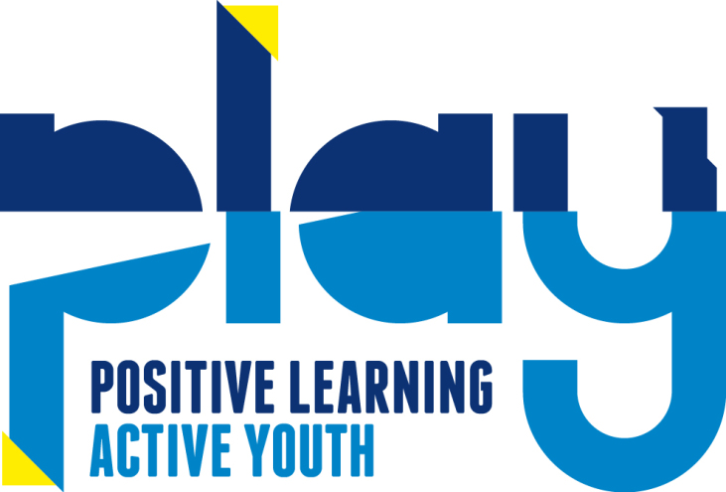

Supporting Children with Special Educational

Needs and Disabilities Statement

Statement of Intent
PLAY at Saltdean, is committed to the belief that all children have a right to be a part of their local community and to be welcomed and included on equal terms in their local after school provision. We draw on all available resources to create an environment within which each child can progress to his/her full potential in all areas of development.

Our practice of inclusion also extends to parents/carers and staff who may have a special need or disability. The setting values the contribution of all adults equally, and will take steps to discuss and resolve any practical issues, which may hinder their participation in the full range of activities (e.g. adapting activities for wheelchair access etc.)

Accessibility to the Premises and Facilities
It is part of our policy to ensure that our provision meets the needs of each individual child:

- We ensure that our physical environment is as far as possible suitable for children with disabilities, liaising with the landlords (BHCC) if further accessibility were needed.

In the event of a child with additional support needs attends PLAY, we give consideration to, for example:

- The arrangement of furniture and fittings to ensure physical access, storing resources at appropriate height, child-height for the wheelchair access. The use of soft furnishings carpets and curtains to absorb sounds and facilitate floor play for the child with sensory or physical difficulties. Using symbols to help children with communication difficulties to express choices or understand what comes next in a series of activities etc.

- We work closely with the child’s parents and any other professionals involved to determine how best we can adapt our curriculum to ensure it is wholly accessible to the child.

- Our flexible curriculum plans already allow for adapting each activity for children at different stages of development. Activities are broken down into appropriate steps so that each child can succeed. When appropriate, 1-1 or small group support is implemented to make situations more accessible for children. We can access the BHCC SEN Inclusion funding for those children with EHCPs.

The setting is further differentiated as appropriate for children with additional support needs by, for example:

- Using props to help maintain attention when storytelling.
- Adapting resources e.g. providing foam grips for paint brushes.
- Adjusting the timetable e.g. by “sandwiching” short periods of structured activity with periods of free play or quiet time etc.
- A ‘safe space’ children can use as a base during the sessions they attend as well as being responsive to their needs at all times. If children are showing to be overwhelmed, staff must work with parent’s and carers to ensure that a positive relationship is established should the session need to be cut short/ soft starts etc.
- Providing assisted places, so that the children can have specific adult support while at PLAY.

Admission Policy regarding children with Additional Support Needs
- The setting is open and accessible to children, irrespective of any special need or disability, and we take steps to include all children in our provision.

- We provide practitioners to support parents and children with Additional Support Needs (ASN)/disabilities. Where a child requires individual support, we will seek the necessary funding and recruit a one-to-one ASN Assistant to work with that child, accessing funding via the EHCP in conjunction with Saltdean Primary School.

- Due to restrictions of space, it may be necessary to limit the number of ASN children who may attend in any one session. Where a child has been denied access to a session for this reason, priority will be given to accommodating him/her in an alternative session.

INCO
The named staff member to act as INCO is Caroline Emment. By liaising with Saltdean Primary SENCO BHCC Inclusion, class teachers and parents, PLAY PE will provide an enabling environment for all children to attend.

- Work closely with children’s key person to identify the specific needs of children with ASN/Disabilities, and to meet those needs through a range of strategies.

- Work in partnership with parents and other professionals in respect of meeting the needs of children with ASN.

- Advise and support other practitioners in the setting.

- Ensure that the relevant background information about individual children with ASN is collected, recorded and updated.

- Keep up to date with current legislation and guidance, through seeking out relevant training courses and consulting with the area INCO and Early Childhood Forum (First Training Programme).

- We require both INCO’S to liaise with the other staff and management of the preschool to monitor and review our practice and provision and, if necessary, make adjustments.

(As stated in the Statutory Framework for the Early Years Foundation Stage 3.67)

SEN Code of Practice
The preschool has regard for the Special Educational Needs Code of Practice, (DfES, 2001), which recommends that early years providers should identify children’s needs and take action to meet those needs as early as possible, in partnership with parents and carers.

In line with the recommendations of the SEN Code of Practice we follow a “graduated response” system to the ASN of individual children. The recommended levels of provision are:

- Early Years Action
- Early Years Action Plus
- EHCP

Our INCO is closely involved in the determination and provision of early years education at all of these stages.

Confidentiality
All records and information concerning children are confidential and are only shared on a “need-to-know” basis; i.e. a child’s key person may discuss concerns with the group’s INCO’S. PLAY will not contact any outside agency regarding the needs of a specific child without the prior consent of the parent/carer.

This policy was adopted by: PLAY | Date: December 2022
To be reviewed: December 2023 | Signed: 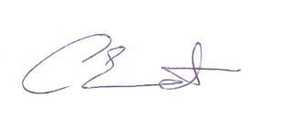

This policy was adopted by the Staff and Management at PLAY, November 2016

Supporting Children with Special Educational

Needs and Disabilities Policy

Statement of intent
At PLAY, we provide an environment in which all children are supported to reach their full potential.

Our Aims

- We have regard for the DfES Special Educational Needs Code of Practice.

- We include all children in our provision.

- We provide practitioners to help support parents and children with additional support needs.

- We identify the specific needs of children with additional support needs (ASN) and meet those needs through a range of strategies.

- We work in partnership with parents and other agencies in meeting individual children’s needs.

- We monitor and review our practice and provision and, if necessary, make adjustments.

Methods
- All children are treated as individuals and with respect.

- Children with additional support needs (ASN), like all other children, are admitted to the preschool after consultation between parents, senior supervisor and key person.

- We designate a member of staff to be an Additional Support Needs (ASN) Co-ordinator (ASNCO) and give his/her name to parents.

- The setting has a trained INCO officers; Caroline Emment.

- We provide a statement showing how we provide for children with additional support needs (ASN)

- We ensure that the provision for children with (ASN) is the responsibility of all the members of the setting. All staff are fully informed of the needs of the child.
- We ensure that our inclusive admissions practice ensures equality of access and opportunity.

- We ensure that our physical environment is as far as possible suitable for children with disabilities.

- We work closely with parents of children with additional support needs (ASN) to create and maintain a positive partnership.

- We ensure that parents are informed at all stages of the assessment, planning, provision and review of their children’s education. Written parental consent is always required before we contact outside help or advice for specific children.

- Parents wishes are respected help will only be sought with permission. However general advice may be looked for on an anonymous basis.

- We work in liaison with staff outside the group, including therapists, health visitors, psychologists, social workers, paediatricians and Portage workers, to meet children’s specific needs and those of their families.

- We provide a welcoming, broad and balanced curriculum for all children with additional support needs (ASN).

- We provide a differentiated curriculum to meet individual needs and abilities.

- We use a system of planning, implementing, monitoring, evaluating and reviewing through individual Education, Health and Care plans.

- We ensure that all children with additional support needs (ASN) are appropriately involved at all stages of the graduated response, taking into account their levels of ability.

- Our system of observation and record keeping, which operates in conjunction with parents, enables us to monitor children’s needs and progress in detail on an individual basis.

- We provide resources (human and financial) to implement our additional support needs (ASN) policy. Where a child’s needs cannot be met without additional personal/equipment, we will seek the necessary ASN funding to enable us to meet those needs.

- We ensure the privacy of children with additional support needs (ASN) when intimate care is being provided.

- Whenever possible staff will attend in-service training on additional support needs. The Early Years Support Service and other professional bodies may also arrange training.

- We raise awareness of any specialism the setting has to offer.

- We ensure the effectiveness of our additional support needs (ASN) provision by collecting information from a range of sources e.g. EHC reviews, staff meetings, parental and external agencies views, inspections and complaints. This information is collated, evaluated and reviewed annually.

- We provide a complaint’s procedure.

- We monitor and review our policy annually.

- All records and information on children will be kept confidential (on a need to know basis).

- The number of sessions offered per week to a child receiving ASN funding and needing additional personal will depend on the preschool’s ability to pay the extra expenses, (not covered by the funding) incurred in employing additional personal.

- Due to restrictions of space it may be necessary to limit the number of children with ASN that may attend in any one session. Where a child has been denied access to a session priority will be given to accommodate him/her in an alternative session.

Links to the Statutory Framework for the Early Years Foundation Stage – Welfare Requirements – Section 5 - Safeguarding and Promoting Children’s Welfare – Equality of Opportunities

This policy was adopted by: PLAY | Date: December 2022
To be reviewed: December 2023 | Signed:

This policy was adopted by the Staff and Management at PLAY, November 2016

