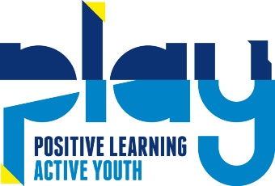

Social Media Policy
PLAY PE recognises that many staff enjoy networking with friends and family via social media. However, we have to balance this against our duty to maintain the confidentiality of children and parents attending our Club, as well as ensuring that our good reputation is upheld. Staff must remember that they are ambassadors for our Club both within and outside of working hours and are expected to conduct themselves accordingly when using social media sites.

This policy covers (but is not limited to) social media platforms such as:
- Twitter
- Facebook
- YouTube
- Tumblr
- TikTok
- Personal blogs and websites
- Comments posted on third party blogs or websites
- Online forums

Social media rules When using social media sites, staff must not:
- Post anything that could damage our Club’s reputation.
- Post anything that could offend other members of staff, parents or children using our Club.
- Publish any photographs or materials that could identify the children or our Club. If photos or videos are shared on our official social media channels, faces and identifying features are blurred and/or covered, usually with an emoji sticker even if parent have given permission on registration forms.
- No real time stories or posts to be shared which could give clues to which children are where at a specific time, such as sports fixtures, holiday clubs etc.
- Accept new invitations from parents to connect via social media (eg friend requests on Facebook) unless they already know the parent in a private capacity.
- Discuss with parents any issues relating to their child or our Club. Instead invite the parent to raise the issue when they are next at the Club, or to contact the Manager if the matter is more urgent. Any member of staff who posts content or comments that breach confidentiality or which could harm the reputation of our Club or other staff members, or who publishes photographs of the setting or children, will face disciplinary action in line with our Staff Disciplinary policy.
- Share any information from a member of staff’s private account with those who are not friends or following that account. Their private account and posts should remain private.

General cautions for using social media
When using social media in any context it is wise to bear in mind the following points:
- Most social media platforms, including Whatsapp have age restrictions for a reason.
- No information published via the internet is ever totally secure; if you don’t want information to become public, do not post it online.
- Once an image or information is in the public domain, it is potentially there forever – Google never forgets!

This policy was adopted by: PLAY | Date: December 2022
To be reviewed: December 2023 | Signed: C Emment
Written in accordance with the Statutory Framework for the Early Years Foundation Stage (2014): Safeguarding and Welfare Requirements: Managing Behaviour [3.52].

