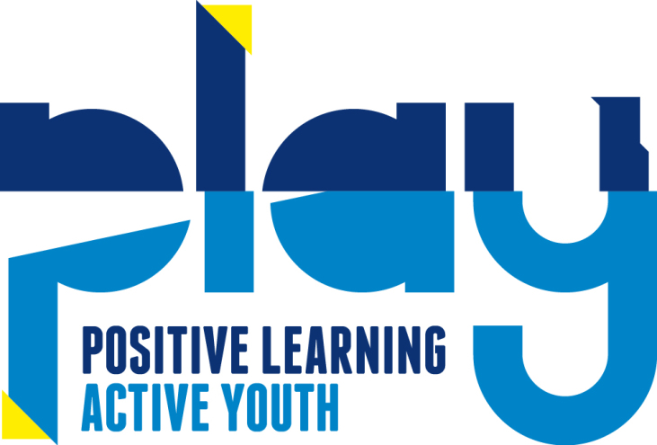
Photography Policy
Use of Mobile Phones, Cameras, Ipads and Tablets
Safeguarding and Welfare Requirement: Child Protection The safeguarding policy and procedures must include an explanation of the action to be taken in the event of an allegation being made against a member of staff, and cover the use of mobile phones and cameras in the setting.
Policy statement
We take steps to ensure that there are effective procedures in place to protect children, young people, and vulnerable adults from the unacceptable use of mobile phones, cameras, IPads and tablets in the setting.
Procedures
Personal Mobile Phones
- Personal mobile phones belonging to all staff and volunteers are not used during working hours.
- Children attending the session will need to hand their phone in or keep the phone secured in their bag in the main hall at all times.
- At the beginning of each individual’s shift, personal mobile phones are stored in the store cupboard in the South Hall and locked during open times or placed in the kitchen.
- In the event of an emergency, personal mobile phones may be used in privacy, where there are no children present.
- Members of staff and volunteers ensure that the work telephone number is known to immediate family and other people who need to contact them in an emergency.
- If members of staff volunteers or parents take their own mobile phones on outings, for use in the case of an emergency, they must not make or receive personal calls/text messages as this may distract them.
- Staff and volunteers will not use their personal mobile phones for taking photographs of children whilst working.
- Parents and visitors are requested not to use their mobile phones whilst in the South Hall. If a visitor’s company or organisation operates a lone working policy that requires contact with their office periodically throughout the day, visitors will be advised of a quiet space where they can use their mobile phone, where there are no children present.
Cameras and Videos
- Staff and volunteers must not bring their own cameras or video recorders into the setting.
- Photographs and recordings of children are only taken for valid reasons, i.e. to record their learning and development, or for displays within the setting whilst children are present.
- Photographs or recordings of children are only taken on equipment belonging to the setting.
- Camera and video use is monitored by the Site Manager.
- Where parents request permission to photograph or record their own children at special events, permission will first be gained from all parents for their children to be included.
- Photographs and recordings of children are only taken of children if parents provide written permission to do so (found on the individual child’s Registration Form).

Laptops /Tablets
- Laptops/Tablets will be used solely for the purposes of accessing PLAY data and documents. If ICT is needed to help support learning, the schools ICT suite will be used, not the PLAY laptop.
- The IPads/Tablets allow us to create an educational tool that is unique for us, the setting and our children.
- Where used, IPads/Tablets will be used to take photographs and video footage of the children; to record their learning and development.
- Photographs and recordings of children are only taken of children if parents provide written permission to do so (found on the individual child’s Registration Form).
- Posting of images/movie on the Internet into a public forum is strictly forbidden.
- Passcodes and facial recognition entry will be set up to help prevent unauthorised use of the iPads/Tablets/ Laptops
- Users are not allow to send, access, upload, download or distribute offensive, threatening, pornographic, obscene, or sexually explicit materials or use the preschools internet/e-mail accounts for financial or commercial gain or for any illegal activity.
- Restrictions will be applied to prevent the downloading of inappropriate music, videos, apps and in-app purchases; these passwords will only be known to the Site Management team.
- If any member of staff is found to be engaging in any of the above, the result will be disciplinary action.
- The IPad/Tablets/ Laptops will be checked every half term for any inappropriate content; if found it will removed immediately and discussions will be held with the relevant member of staff.
- The IPads/Tablets/ Laptops will be stored in a locked drawer unit in the South Hall store cupboard. The key is only held by the directors/Managers.

This policy was adopted by: PLAY | Date: December 2022
To be reviewed: December 2023 | Signed: 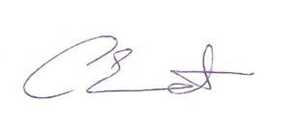

This policy was adopted by the Staff and Management at PLAY, November 2016

